**Managing Azure logic apps task via Universal Controller:**

**Requirement:**

* Trigger Azure logic app job through universal controller
* Universal Controller to monitor the logic app job in Azure till the execution is complete
* Universal controller to fetch the azure logic apps job logs post completion
* Universal controller should have the capability to pass the input parameter in JSON for Azure logic app jobs.

**Technical solution for Managing Azure logic apps through Universal Controller:**

Below picture gives the depiction integrating Azure logic apps with universal controller.

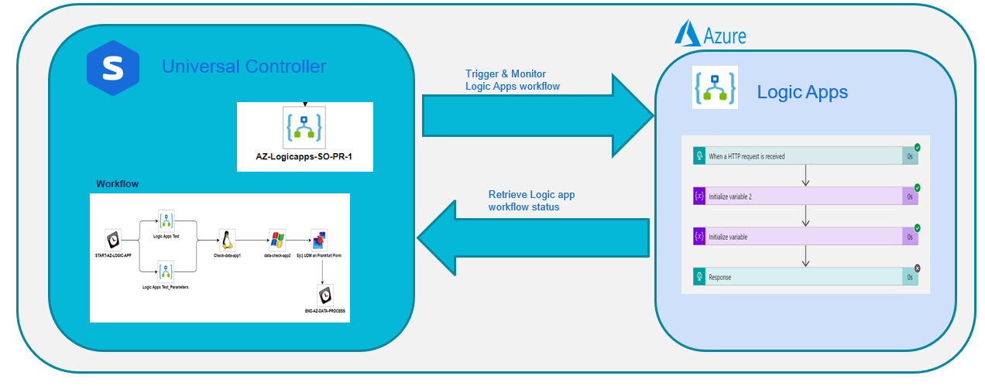

Details below provides the components involved in this integration.

* **Universal controller:** 
  + Universal task – Azure Logic Apps is created in the universal controller and its integrated with Azure cloud platform – Logic Apps through the Rest-API’s
  + Through this Universal task the universal controller can perform the below operations with respect to Azure logic apps
    - Trigger an Azure logic apps workflow
    - Pass dynamic input parameter to the Azure logic app workflow
    - Monitor the execution of azure logic workflow
    - Execute dependent jobs in other platform based on successful execution

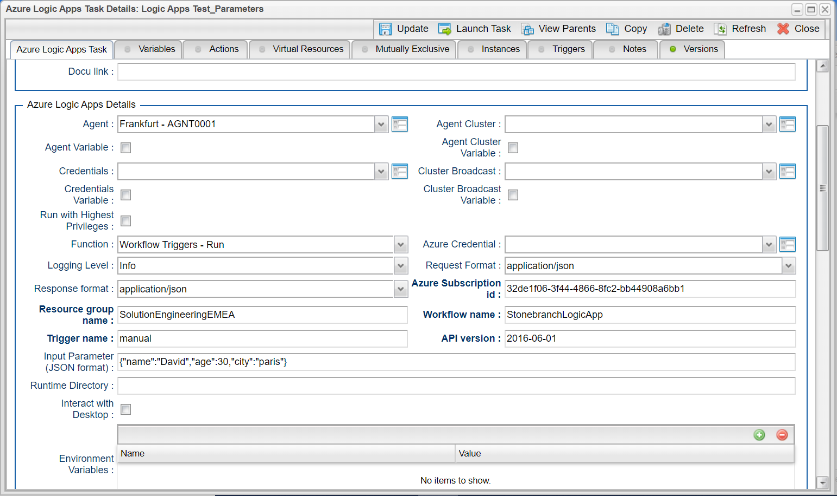

* **Azure Authentication:**
* Logic Apps provides Rest-API’s where this can be used by any 3rd party systems securely through Oauth2.0 authentication mechanism
* The access token generated will get expired every hour, so the access token needs to regenerated using the Refresh token.
* Universal task for logic apps will use the global variable: Azure_access_token to use the access token and this will be used to make the REST-API calls authenticated from universal controller to Azure logic apps
* **Azure Logic Apps:**

It is a Azure cloud service that helps schedule, automate, and orchestrate tasks, business processes, and [workflows](https://docs.microsoft.com/en-us/azure/logic-apps/logic-apps-overview#logic-app-concepts) and its helps to integrate apps, data, systems, and services across enterprises or organizations using the out of the box connectors for 200+ apps. Every logic app workflow starts with a trigger, which fires when a specific event happens, or when new available data meets specific criteria

Also there are certain limitations where it provides only the basic scheduling capabilities for the workflow , setting up dependencies across other platforms could be quite challenging and when the number of logic apps workflow increase its difficult to manage all schedule and execution of logic apps within the native setup.

* **Oauth2.0 Authentication setup in Universal controller Webservices Task**:
  + Follow the below URL to get the initial Bearer token from Azure
    - <https://docs.microsoft.com/en-us/azure/active-directory/develop/v2-oauth2-auth-code-flow>
    - Ensure appropriate options are selected for accessing logic apps in  [Azure portal – App registrations](https://go.microsoft.com/fwlink/?linkid=2083908)
  + Once the initial Bearer access token and the refresh token is obtained you may create the webservice task in universal controller for periodically refreshing the access tokens
  + Below screen shot provides the sample webservice task in universal controller where it has supplied with necessary parameter to make API calls to Azure to get the bearer access token - Please note that in the example the refresh access token / client secret key is passed through universal controller variable (global or task variable)

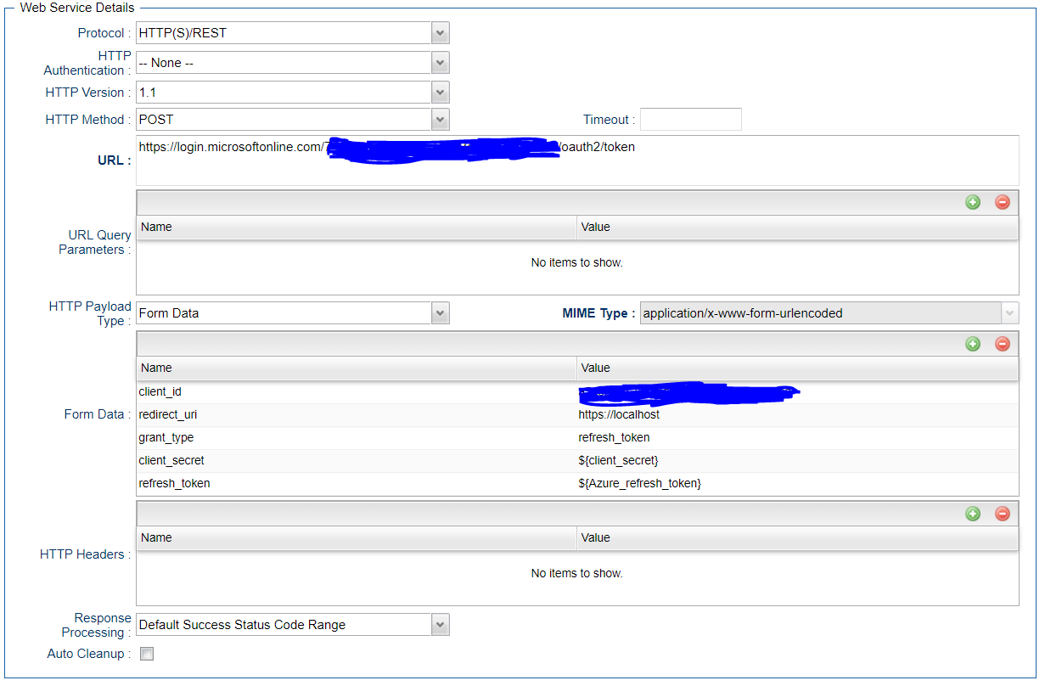

* + Additionally, you may need to configure the below in the action tab of webservice task to set the new access token and refresh token to the universal controller variable

